1. **Dataset**

NMR data containing 48 named metabolites for 24 subjects (12 healthy controls and 12 with heart failure). Additionally, it has some data on exhaled breath that I can use for further comparison. The data set can be found here: [Salivary Dataset Metabolomics Workbench](https://www.metabolomicsworkbench.org/data/DRCCMetadata.php?Mode=Project&ProjectID=PR000430).

1. **Significance**

Cardiovascular disease is one of the leading causes of death worldwide and will continue to grow due to increasing life expectancies. Determining biomarkers for diseases is an essential step leading to the development of novel sensors for their quantification. In this proposal we will primarily target identification of easy access biomarkers found in saliva for diagnosis of early stage heart failure and disease progression. Currently, the gold standard for heart failure prognosis/progression is through the detection of cardiac troponin I 1, N-terminal B-type Natriuretic peptide 2, and B-type natriuretic peptide 3 in blood. Both of these biomarkers will see elevated levels due to increased damage of cardiac muscles which is a proper indication of heart failure 1-3.

Current methods for detection of cardiac troponin I utilize electrochemiluminescence which has a number of disadvantages such as being time-consuming, having low precision, and is difficult to automate making it unsuited as a bedside point-of-care (POC) technique 4. Additional methods for cardiac troponin I utilize ELISAs which suffer from similar disadvantages as the electrochemiluminescence approach. Similarly, detection of BNP utilizes time-consuming and costly techniques by applying mass spectrometry methods which also requires complex sample preparations 5. Although many novel POC nano/bio-sensors have been developed to detect these biomarkers 6, there has been some difficulty due to their complexity, requiring sample preparations and extremely low concentrations 0.04-0.39 ng/mL 7, and < 100 pg/mL 3 for normal troponin and BNP, respectively.

1. **Objectives**

Here we will discuss an analysis of various metabolites in saliva between two groups, healthy controls and those with decompressed heart failure. Furthermore, a certain number of metabolites were detected from exhaled breath and they will be compared to their salivary counterparts. The aim is to identify biomarkers in an easy access medium such as saliva for heart failure. Utilizing saliva as a matrix for detection will reduce the need for an invasive blood sample and will require no preparation for sample acquisition.

1. **Methodology**

For the time being, the t-test will be used to determine differences between the metabolites found in saliva for HF and control groups. Furthermore, an additional data set was found utilizing the exhaled breath for the same groups so a comparison will be made between the saliva and breath data sets. To isolate if metabolic profiles (i.e., differences between multiple metabolites) could correlate more clearly to HF PCA will be performed on the dataset and clusters will be compared.

1. **Results and Discussion**

To isolate significant metabolites in salivary samples between control and heart failure groups, ANOVA was applied to the data and the p-values were determined. After performing this analysis, 5 statically significant (p<0.05) metabolites were identified including Alanine, Dimethylamine, Isopropanol, O-Phosphocholine, and Tyrosine and are presented in Figure 1.

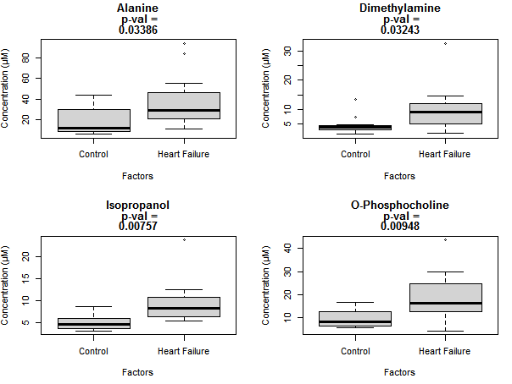

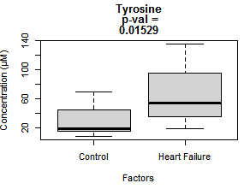

**Figure.1.** Shows the statistically significant salivary metabolites between control (n=12) and heart failure (n=12) groups with p < 0.05.

The biomarkers identified are well correlated with heart failure and their effects on heart health have been previously identified. Dimethylamine has been found to increase systolic blood pressure (SBP), diastolic blood pressure (DBP), and rate pressure product (RPR) in a dose-dependent manner 8. It is well known that patients with increased blood pressure or hypertension are more susceptible to heart failure which further validates the significance of this metabolite. Isopropanol has also been identified to cause an increase in blood pressure9.

O-Phosphocholine which is also known as choline phosphate is a precursor of choline for acetylcholine synthesis10. Acetylcholine is an important neurotransmitter in the parasympathetic nervous system that has been found to promote heart health 11. An increase in Phosphocholine could be looked at from two directions that could result in the development of heart disease. First, an increase in O-Phosphocholine could signify the lack of conversion to choline and result in a decrease in acetylcholine which in turn will limit its capabilities at promoting hearth health. Second, we can consider an increase in Phosphocholine as an increase in production to accommodate the pathway of acetylcholine production to specifically modulate heart health. However, more work needs to be done to identify the effects of Phosphocholine on acetylcholine production.

Previous studies have identified that an increased dosage of Tyrosine can cause tachycardia and hypertension12. However, there is conflicting information on the matter since another study found a decrease in DBP and no effects on SBP and heart reate13. Although the results in this study shown no change on blood pressure, it is worth noting that the subjects were under stress during the measurements. Similar results were found on the effects of tyrosine on rats, where the administration resulted in a decrease in blood pressure14. On the other hand, Tyrosine is an important non-essential amino acid on the synthesis of neurotransmitters and has found to increase acetylcholinesterase activity in rats15. An increase in acetylcholinesterase activity usually indicates a lower efficiency of acetylcholine signaling due to the dramatic decrease in its concentration in the cholinergic synapse. Given a decrease in acetylcholine concentration, we can further relate this to the previously mentioned point where acetylcholine can aid in heart health modulation.

Finally, Alanine is an amino acid that is used in the synthesis of proteins and is also used to break down tryptophan. Positive associations have been previously identified between alanine and higher blood pressure17. After identifying these 5 significant biomarkers between the two groups, principle component analysis (PCA) was applied to determine whether overall metabolomic signatures could be used to isolate the differences between the two groups. The results of PCA are presented in Figure 2.

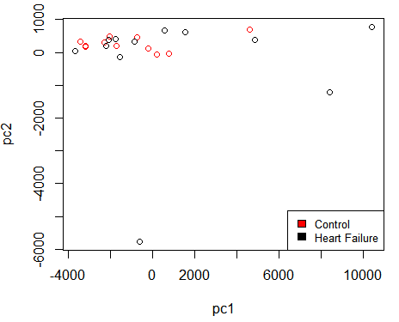

**Figure.2.** Shows the PCA for identified salivary metabolites colored by control and heart failure groups.

As can be seen in the PCA, there is no clear grouping between the control and heart failure patients when considering all metabolites utilized in this analysis. Given that we identified 5 statistically significant metabolites out of 22, it seems natural that no exact grouping would be obtained due to the insignificance of the remainder. Initially, an analysis of breath metabolites was to be compared with their salivary counterparts; however, the lack of diversity in detected metabolites and sub-detectable concentrations of those identified made it impossible for comparison. Therefore, we will conclude without analyzing what little NMR breath data was available.

1. **Conclusion**

Utilization of NMR data for salivary metabolites has allowed the identification of 5 metabolites: Alanine, Dimethylamine, Isopropanol, O-Phosphocholine, and Tyrosine with p-values of 0.03386, 0.03243, 0.00757, 0.000948, and 0.01529, respectively. Previous studies outlining the effects of these metabolites on heart health has provided supportive evidence that they are indeed affected by or directly affect heart health. Additionally, we identify the possible importance on studying acetylcholinesterase and acetylcholine, and their pathways as it pertains to patients with heart disease. In conclusion, these identified metabolites and their supporting biological roles have given insight on potential biomarkers for heart health prognosis in decompressed heart failure patients.

**References**

1. Babuin, Luciano, and Allan S Jaffe. “Troponin: the biomarker of choice for the detection of cardiac injury.” *CMAJ : Canadian Medical Association journal = journal de l'Association medicale canadienne* vol. 173,10 (2005): 1191-202. doi:10.1503/cmaj/051291
2. Moe, G.W., Howlett, J., Januzzi, J.L., Zowall, H., 2007. N-Terminal Pro–B-Type Natriuretic Peptide Testing Improves the Management of Patients With Suspected Acute Heart Failure. Circulation 115, 3103–3110.. doi:10.1161/circulationaha.106.666255
3. Dao Q, Krishnaswamy P, Kazanegra R, et al. Utility of B-type natriuretic peptide in the diagnosis of congestive heart failure in an urgent-care setting. *J Am Coll Cardiol*. 2001;37(2):379-385. doi:10.1016/s0735-1097(00)01156-6
4. Ravalli, Andrea et al. “Electrochemical, Electrochemiluminescence, and Photoelectrochemical Aptamer-Based Nanostructured Sensors for Biomarker Analysis.” *Biosensors* vol. 6,3 39. 2 Aug. 2016, doi:10.3390/bios6030039
5. Niederkofler EE, Kiernan UA, O'Rear J, et al. Detection of endogenous B-type natriuretic peptide at very low concentrations in patients with heart failure. *Circ Heart Fail*. 2008;1(4):258-264. doi:10.1161/CIRCHEARTFAILURE.108.790774
6. Kim, K., Park, C., Kwon, D., Kim, D., Meyyappan, M., Jeon, S., Lee, J.-S., 2016. Silicon nanowire biosensors for detection of cardiac troponin I (cTnI) with high sensitivity. Biosensors and Bioelectronics 77, 695–701.. doi:10.1016/j.bios.2015.10.008
7. Newby LK, et al. ACCF 2012 expert consensus document on practical clinical considerations in the interpretation of troponin elevations: a report of the American College of Cardiology Foundation task force on Clinical Expert Consensus Documents. *J Am Coll Cardiol* 2012, 60:2427-63.
8. Bloomer RJ, Harvey IC, Farney TM, Bell ZW, Canale RE. Effects of 1,3-dimethylamylamine and caffeine alone or in combination on heart rate and blood pressure in healthy men and women. *Phys Sportsmed*. 2011;39(3):111-120. doi:10.3810/psm.2011.09.1927
9. Zhao, Z., Liu, X., Xing, X., Lu, Y., Sun, Y., Ou, X., Su, X., Jiang, J., Yang, Y., Chen, J., Shen, B., He, Y., 2016. The Activation Effects of Low Level Isopropyl Alcohol Exposure on Arterial Blood Pressures Are Associated with Decreased 5-Hydroxyindole Acetic Acid in Urine. PLOS ONE 11, e0162762.. doi:10.1371/journal.pone.0162762
10. Blusztajn JK, Liscovitch M, Mauron C, Richardson UI, Wurtman RJ. Phosphatidylcholine as a precursor of choline for acetylcholine synthesis. *J Neural Transm Suppl*. 1987;24:247-259.
11. Roy, A., Fields, W.C., Rocha‐Resende, C., Resende, R.R., Guatimosim, S., Prado, V.F., Gros, R., Prado, M.A.M., 2013. Cardiomyocyte‐secreted acetylcholine is required for maintenance of homeostasis in the heart. The FASEB Journal 27, 5072–5082.. doi:10.1096/fj.13-238279
12. Ekholm S, Karppanen H. Cardiovascular effects of L-tyrosine: influence of blockade of tyrosine metabolism. *Eur J Pharmacol*. 1989;163(2-3):209-217. doi:10.1016/0014-2999(89)90189-1
13. J.B Deijen, J.F Orlebeke,. Effect of tyrosine on cognitive function and blood pressure under stress, Brain Research Bulletin,Volume 33, Issue 3,1994,Pages 319-323,ISSN 0361-9230, https://doi.org/10.1016/0361-9230(94)90200-3.
14. Sved, A F et al. “Tyrosine administration reduces blood pressure and enhances brain norepinephrine release in spontaneously hypertensive rats.” *Proceedings of the National Academy of Sciences of the United States of America* vol. 76,7 (1979): 3511-4. doi:10.1073/pnas.76.7.3511
15. Gabriela K. Ferreira, Milena Carvalho-Silva, Cinara L. Gonçalves, Júlia S. Vieira, Giselli Scaini, Fernando V. Ghedim, Pedro F. Deroza, Alexandra I. Zugno, Talita C.B. Pereira, Giovanna M.T. Oliveira, Luiza W. Kist, Maurício R. Bogo, Patrícia F. Schuck, Gustavo C. Ferreira, Emilio L. Streck,
16. l-Tyrosine administration increases acetylcholinesterase activity in rats,Neurochemistry International,Volume 61, Issue 8,2012,Pages 1370-1374,ISSN 0197-0186,https://doi.org/10.1016/j.neuint.2012.09.017.
17. Tuttle KR, Milton JE, Packard DP, Shuler LA, Short RA. Dietary amino acids and blood pressure: a cohort study of patients with cardiovascular disease. *Am J Kidney Dis*. 2012;59(6):803-809. doi:10.1053/j.ajkd.2011.12.026